附件2

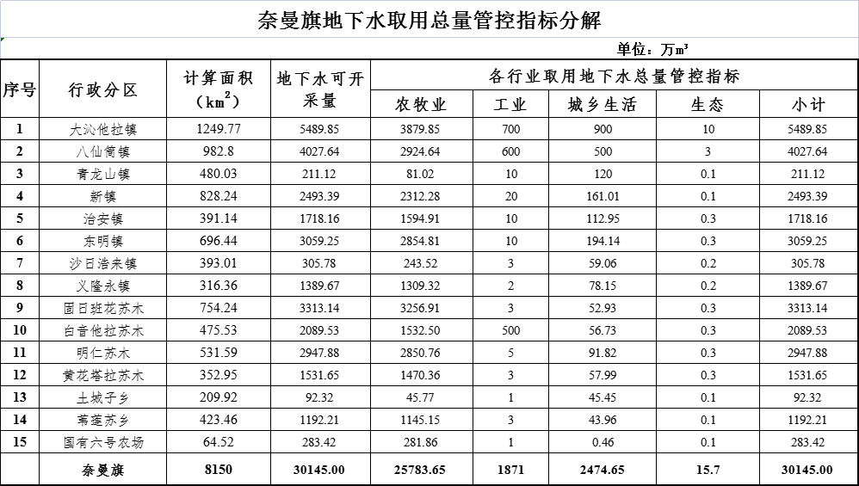

## 49000eeb22e7707d7d2825fa9fd7ccb